Dear Applicant

Training and Development Co-Ordinator for Child Contact Centres

£35,492 - £40,353 (pro-rata)

(21 hours per week)

Thank you for your interest in the post above. Please find attached all the relevant information you will need to complete your application.

To apply, please send us:
- An up-to-date CV
- A supporting statement (max 2 pages) that outlines your interest in our organisation and this role, and your fit against the criteria set out in the person specification and job description.
- Details of two people who could provide a reference for you. References would only be taken up if an offer of employment is to being made and only with your prior agreement.

Please e-mail us at recruitment@relationships-scotland.org.uk or by post to:

Private and confidential
Diana Sinclair
Relationships Scotland
18 York Place
Edinburgh EH1 3EP

The closing date for completed applications is 5pm on Monday 27th April 2026 and interviews will be held in person at 18 York Place in Edinburgh on Friday 8th May 2026.
We look forward to receiving your application.

Relationships Scotland

Summary of Key Terms and Conditions
- Permanent contract*
- 21 hours per week
- The jobholder must be eligible to work in the UK
*Whilst this is a permanent post, we currently have funding in place for 3 years and hope to identify ongoing funding after that time.
Benefits of Working at Relationships Scotland
We offer the following benefits to all employees:
- Annual leave of 30 days plus 7 public holidays per year (prorated for part-time employees)
- Flexible working hours in line with the needs of the organisation
- A generous employer contribution to our nominated pension fund with the option for employees to contribute as well or to opt out of the scheme.
- Enhanced company schemes for
  - sick leave
  - maternity leave
  - parental leave

Communication and collaboration:
- Line Managers have an initial appraisal with employees after 3 months of employment, then annual appraisals
- We hold regular staff team meetings
- There is an annual staff survey
- A staff forum meets 3 or 4 times each year
- There are two annual staff outings for all staff (summer and Christmas)


Job Description: Training and Development Co-Ordinator for Child Contact Centres

This job description describes the practical purpose and main elements of the job. It is a guide to the nature and main duties of the job as they exist currently but is not intended as a wholly comprehensive or permanent schedule.

- Job Details
- Job title: Training and Development Co-Ordinator for Child Contact Centres
- Reports to: Head of Professional Practice for Child Contact Centres

- Overall Purpose of the job
- To develop and deliver a program of CPD and the Introduction to Child Contact Centres course
- To develop and implement a training development framework for child contact centre staff
- To develop resources and support child contact centres in their preparations for the Regulation of Child Contact Centres and future inspection

Organisational Structure
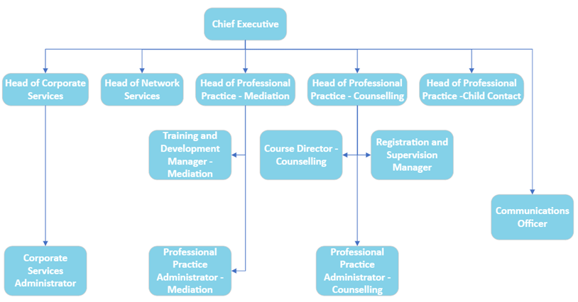

Principal Accountabilities

- Develop and deliver a full range of training and development opportunities for practitioners delivering child contact services in Scotland (In the network and wider).
- Develop and provide support, training and resources for child contact centre staff to prepare regulation and inspection.
- Be responsible for your own administrative duties in relation to this post.
- To develop and implement a development framework for child contact centre staff
- Support with the development of a child contact centre register
- Work in partnership with network chief officers, managers, practitioners and other key stakeholders
- Work with Care Inspectorate to ensure that the support, training and resources are in line with the Quality Improvement Framework for Child Contact Centres to support settings fully.
- Ensure that the content of training and development courses is relevant, and improve the practice of practitioners and the quality of services for children, young people, parents and families
- Ensure that there is a strong focus on developing trauma-informed practice, domestic abuse informed practice, emotional health and wellbeing and relational approaches
- Maintain and update the eLearning platform (Moodle) for CCC courses to promote access, inclusion and flexibility for learners
- Continue to develop effective assessment processes to monitor learning outcomes
- Work with managers to develop effective approaches for embedding learning into practice and evaluating the impact on practice improvement and on service delivery
- engage with learners in reviewing progress, identifying gaps in learning and providing further learning opportunities and refresher courses
- Develop approaches to evaluating courses, including the impact on service users and produce regular reports
- Improve the content of the practice handbook for child contact practitioners including updating policies and procedures and ensure that the code of practice for child contact centre practitioners is up to date and relevant.
- Support managers and practitioners in the implementation of the UNCRC through the development of a toolkit and resources for seeking the views of children and young people and ensuring that relevant articles are considered in child contact work
- Working in partnership with Fife College, take forward course accreditation, developing external assessment and validation of courses in training child contact managers as internal assessors
- Attend and report to the Child Contact Centre Committee when appropriate.
These key tasks are not intended to be exhaustive, but they highlight several major tasks that the post-holder may be reasonably expected to undertake.

Additional Context
Every job description in the organization will be subject to a review either:
- On an annual basis at the time of the annual appraisal meetings, or
- As a result of a change in strategic direction, or
- As a result of team/operational requirements, or
- As a result of agreed performance appraisal needs and objectives, or
- Within six months of appointment

Person specification – Training and Development Co-Ordinator for Child Contact Centres

Attributes | Essential | Desirable
Qualifications | Educated to degree level or equivalent
Specialist Skills & Experience | Experience of developing and delivering training and development opportunities, preferably in the health and social care sector  An understanding of the current policy context for working with children, young people, and families  An understanding of monitoring and evaluation processes  An understanding of trauma – informed practice  An understanding of child protection and safeguarding | Experience in working with further and higher education providers  Understanding of Qualifications Scotland, accreditation and assessment  Experience in developing and delivering train the trainer courses  An understanding of family law  An understanding of domestic abuse – informed practice  An understanding of the regulatory processes of the Care Inspectorate
Personal Qualities | Excellent communicator – both verbally and in writing  Ability to work under pressure, meet deadlines and prioritise own workload  Commitment to delivering quality services for children, young people, and families  Commitment to equality, diversity and inclusion  An understanding of trauma-informed practice

